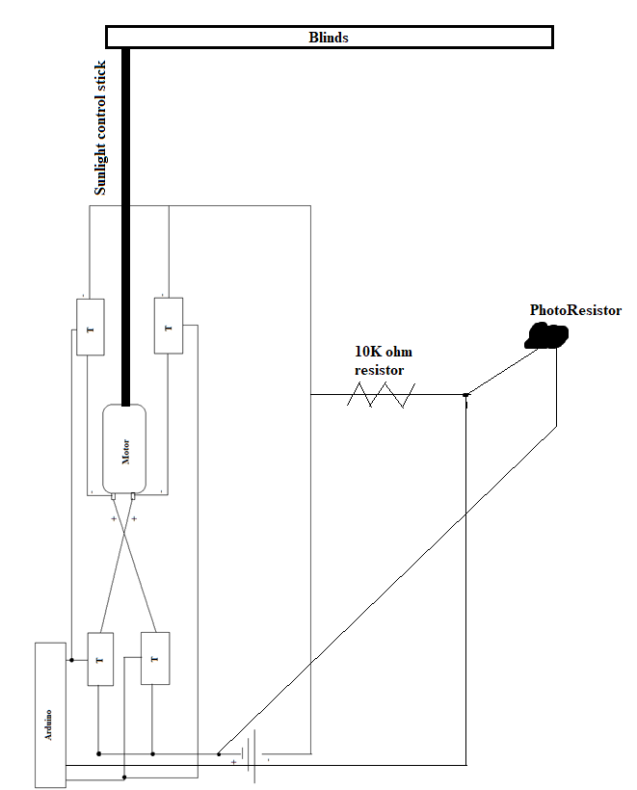

The Arduino will read analog values coming from the photoresistor, and send voltage through a digital pin to activate the circuit of 2 of the transistors, and let current pass through that. This will control the direction of the motor. The motor will be controlled using time to make sure it doesn’t overshoot the desired daylight.